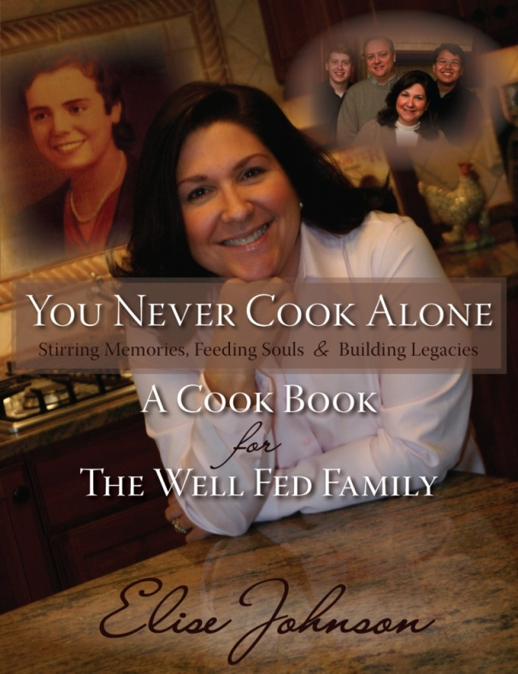
You Never Cook Alone
Description

You Never Cook Alone delights cooks whether novice or expert. Hundreds of easy-to-follow recipes are combined into dozens of tasty meals that will please any family or gathering of friends.

You Never Cook Alone is divided into two main sections: “Eventful Meals” and “No Passport Necessary”.

Eventful Meals builds complete menus from Elise’s favorite recipes to create memorable cooking and dining experiences the whole family will enjoy. Chapter titles like “It’s More Than Pizza” or “A Murder Mystery Dinner” entice you to try various recipe combinations and turn busy weekday meals into your own happenings to be savored.

The second section of the cookbook is titled “No Passport Necessary – Expanding Your Family’s World One Meal at a Time”. Through regional, ethnic and international cuisine, Elise will show you how take your family around the world, just as she helped her own children to explore the world through food.

Adding spice to the recipes, you’ll find glimpses into Elise’s life scattered among the menus. But, be prepared! Some stories may bring a smile and chuckle, while others may produce a full belly-laugh as if you were around the table with Elise. You may even need a tissue or two to dab the tears on occasion.

All of the recipes, meals and stories are fully indexed so you can quickly find just what you need as you contemplate your own meal preparations.

Elise hopes that you’ll learn to cook with her grandmother’s secret ingredient – love.

You Never Cook Alone invites you into Elise’s world of “Stirring Memories, Feeding Souls and Building Legacies” so that you and your loved ones can become a truly “Well-Fed Family” – spiritually, emotionally and relationally… as well as physically.

High resolution photos may be downloaded along with other backgrounders from
www.CookingwithElise.com/Newsroom

